Predicting Mobile Phone Price Range Using Machine Learning
and Deep Learning

By Alistair Chua (ac2160)
23010554

Introduction
With the improvement of technology on mobile phones, many companies have entered the competition of manufacturing the new phone. Leading to various phones to release with different specifications. However, to be able to compete in today’s industry, the manufacturer has to understand how a hardware specification takes part into the value of their product. Machine learning has grown into a complex and useful tool for the industry, allowing us to involve the use of predictive models into estimating the mobile’s phone price range, taking into account the different hardware specifications prevalent in the production of the phone.
With a wide range of machine learning models in price range determination, this investigation aims to explore the consistency and accuracy of predicting mobile phone price ranges through the use of hardware specification alone. Each model will be compared to pinpoint features of the model which are most influential on the prediction of price range

Data Description

For this analysis, the dataset used is the Mobile Price Classification Dataset found on Kaggle (Appendix 1.). The dataset contains hardware specifications on 2000 different mobile phones. There are 21 variables, one of the variables is the target variable which is categorical and represents the phone’s price range. The other 20 are the predictor features which are all numerical. Two datasets were provided in the Kaggle link, “train.csv” and “test.csv”. However, the “train.csv” dataset will be the main focus.
This dataset was chosen for this investigation because of its huge range in records, making the dataset a more reliable source for the models to create predictions. Furthermore, the dataset has a balanced distribution for the target variables, ensuring an unbiased training environment for the models.

Target Variable:
The target variable in the dataset is “price_range”, it is split into 4 different classes: these represent 0 (low cost),1 (medium cost),2 (high cost) and 3 (very high cost). The categories represent the market value that the phones will go for. The models will also be referring to these to determine outcomes.

Predictor Variables:
The dataset included variables of specifications found commonly in most mobile devices on the market. Although there are 20 predictor variables which are used during prediction, the analysis will only take into account the details of the strongest predictors. The strongest predictors will be explored in the “Data Exploration” section

Methodology
Data Preparation
Before using the classification models on this dataset, the data needed to be prepared for use. First, any missing values were identified, in this dataset had no missing values, therefore no rows were needed to be removed. For consistency and reproducibility, the train/test split used for each model was a 70/30 split, 70% training set and 30% testing set. Thereafter, our target variable “price_range” was converted depending on its required use.
Models used for analysis
The following models were chosen to be compared with each other to test which is the most accurate and efficient at predicting the mobile’s price range, when only using the given hardware specifications in the dataset.
GLM
This model assesses whether the relationship between the hardware specification and the price range are linear. Multinomial Logistic Regression was used in this model as there were multiple variables.
Deep Learning via Keras
The dataset has non-linear interactions that other models may not analyze well. Therefore, using a neural network is suitable as they are designed to model non-linear patterns and are able to make predictions based upon them.
Decision Trees and Random Forest (RF)
Decision trees were chosen as it allows the interpretation of different decision rules made when predicting a price range and the hierarchy among them. Further investigation using RF enables the model to take multiple decision trees and link them together to produce a more accurate prediction model.

Results

This section presents the performance of each machine learning model that was used to predict the price range. Each model was trained using the same seed and train/test split, mainly evaluated based on accuracy and confusion matrix

Data Exploration:
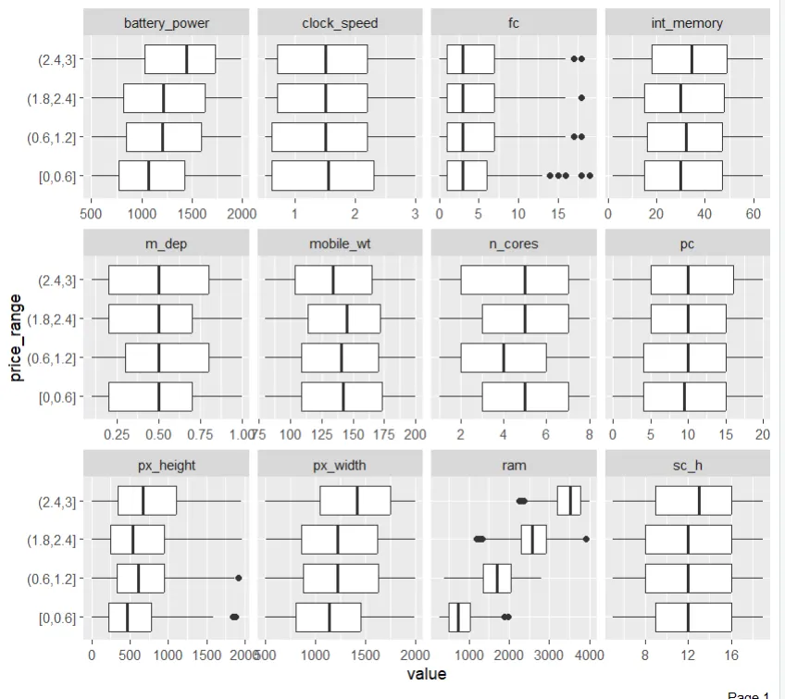
Figure 1.(price_range vs variable value boxplots
The data has a presence of weak predictors as some features shows overlapping boxplots between the price ranges resulting in a minimal contribution to our predictions. However, a select few are shown to be strong predictors. RAM, battery power and pixel resolution (px_width and px_height). RAM was the strongest predictor as it shows the clearest separation between price ranges. The second strongest was pixel resolution as a clear gradual increase in value as we go up the price is seen. The least strong was battery power as it does present a positive relationship between price and power, but an overlap is still slightly prevalent, however it is strong enough to be able to be used as a predictor.
GLM
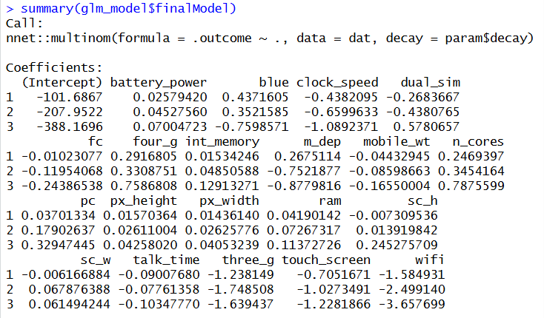

Figure 2 (Summary of GLM)
The GLM coefficients highlighted several features which strongly influenced the price range of a phone. RAM has the largest positive effect across all price range classes. Pixel resolution and battery power also appear to have consistent positive coefficients. However, features such as clock speed and talk time show mostly negative coefficients which suggest a small contribution to the predictions. This GLM result is consistent to the boxplot results of RAM, pixel resolution and battery power being the strongest

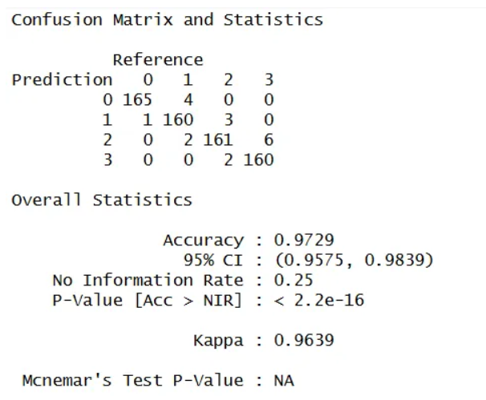

Figure 3. Confusion matrix values for GLM
A confusion matrix was executed on the GLM model which showcases the predictive accuracy of its price ranges. It achieved a near perfect accuracy of 97.29%, this suggests that GLM is good at determining outcomes on unseen data. In addition, the p-value is less than 0.05, implying that the results are a significant factor. The main focus of the matrix is the diagonal shown, this shows how many were correctly predicted.

Decision Trees and RF
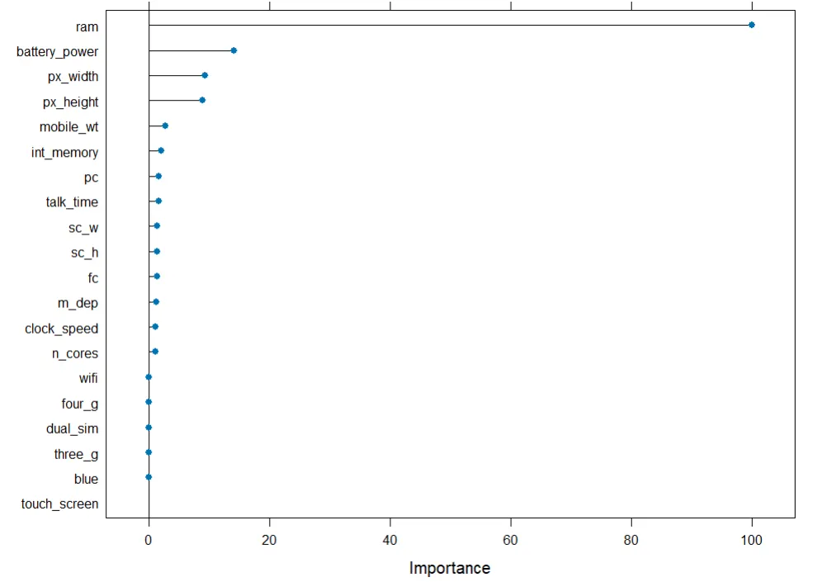
A Variable Importance Plot (VIP) was performed, to further investigate which variable had the most importance in prediction.

Figure 4. Variable Importance Plot

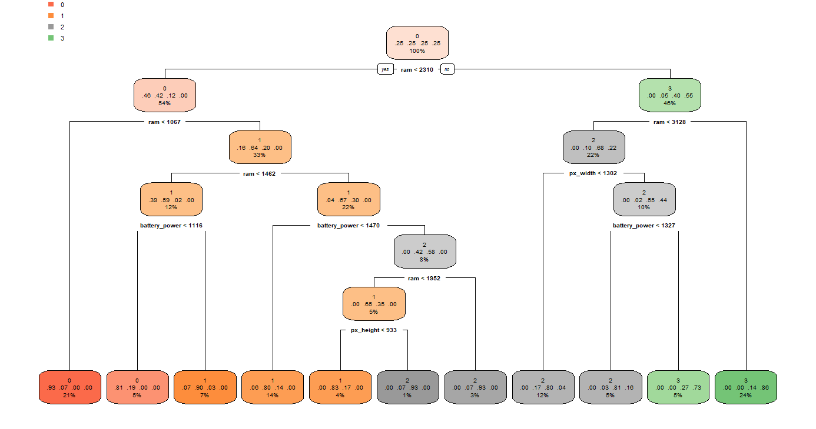
Consistent with our previous findings, the VIP shows that RAM, battery power and pixel resolution remain to be the most important variables. In contrast to the boxplots, battery power is shown to have more importance than pixel resolution here. This is because VIP measures the predictive power by the splits from the tree, instead of analysis of univariate separation. Furthermore, the weight of the mobile phone and the internal memory are shown to play a small part in the output but not as significant as the top 4.

Figure 5 (Decision Tree Representation of RF)
The decision tree demonstrates that RAM is the most significant predictor, being set as the root node and separating the branches from low end to high end prices. RAM being less than 1067 MB has a high probability of being predicted to be 0, whilst having 3GB or more are most likely to be predicted to be 3. In between the price ranges of 1-2, the model takes into account features, battery power and pixel resolution. Overall, the results remain consistent that hardware specifications predict mobile phone’s price range.

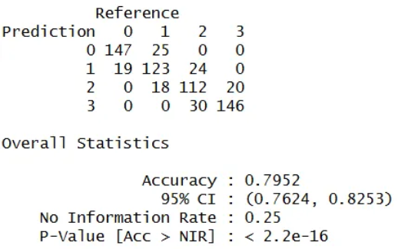

Figure 6. Confusion matrix for RF
Continuing with the previous, another confusion matrix was performed on the model, resulting with a predictive accuracy of 79.52%, In comparison to GLM, the amount of correctly predicted results drastically drops, this links back to the lower predictive accuracy this is might be because of the amount of noisy data in the dataset that wasn't involved in the trees which negatively impacted the predictive accuracy

Deep Learning using Keras
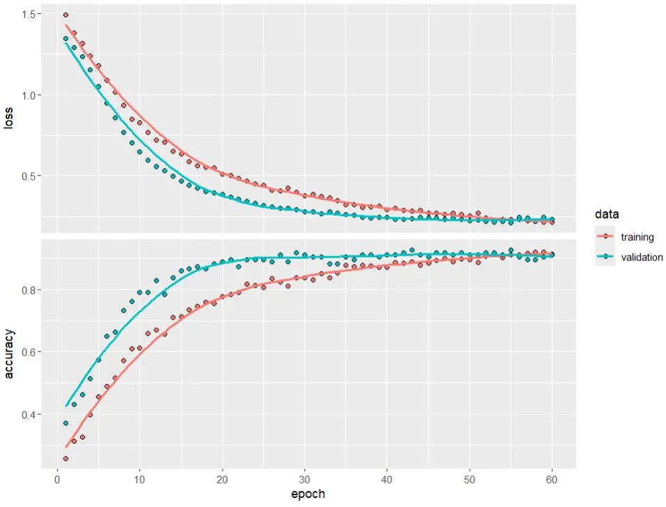
Figure 7. Loss/Accuracy vs epoch using training set and validation
Above shows the behaviour of the loss and accuracy of the training set against the validation set. To produce this, 60 epochs have been used, with the first layer having 40 neurons and the second having 20 neurons with a dropout rate of 30%. The graph above shows that the model fits the data well as it doesn’t have any sudden spikes or dips. No overfitting is shown as the validation loss did not show an incline. On the 55th epoch, the sets converged which represent that they have both settled on a value that would output accurate predictions.
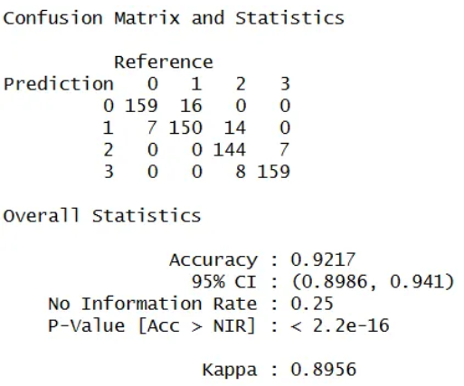

Figure 8. Confusion matrix for Deep Learning

A confusion matrix has been conducted on this model, displaying an high predictive accuracy of 92.17% which is better than RF but still doesn't perform as well as GLM. This model still performs very well on this dataset on predicting price ranges using only the hardware specs.

Conclusion

In this investigation, the aim was to determine whether a mobile phone’s price range could be accurately predicted using machine learning models based solely on the hardware specifications provided by the dataset. Among the four models that were tested, they all provided results that consistently showed a strong predictive performance, all achieving high accuracies when executing the confusion matrices. This suggests that hardware specifications provide enough information to predict a mobile phone’s price range on the market.

Although GLM performed with the highest predictive accuracy, RF and Deep Learning allowed for the exploration of the complex interactions between the predictor variables. Furthermore, the decision tree representation of RF enabled the ease of interpretability showcasing the hierarchical structure of the variable importance, showing clearly that RAM was the most dominant predictor; followed by battery power and pixel resolution. However, GLM presented the linear relationship of some variables with the price range, the linearity may be the cause of its exceptionally high predictive accuracy.

Ultimately, the results show evidence that mobile phone price ranges can be accurately predicted through machine learning models only using hardware specifications. This suggests that companies and consumers could utilize these models to determine a price range based on hardware. Further improvements to the predictions could include more real-world features such as brand or design of the phone, this would allow for a more in-depth prediction of the price range.

Appendix

- Appendix 1. Mobile Price Classification https://www.kaggle.com/datasets/iabhishekofficial/mobile-price-classification/data

- R code used:
## Mobile Pricing Range Classification,
#can we predict mobile price range using hardware specifications provided by the data set?
#which models perform the best?
#Using GLM, Deep Learning (via Keras), Random Forest (w decision tree), SVM

##loading libraries needed
library(tidyverse)
library(ggplot2) #for plotting graphs
library(DataExplorer)
library(caret)
library(nnet)
library(keras) #deep learning
library(randomForest)#random forest section
library(rpart)
library(rpart.plot)
print("loaded")

#loading csv file into a dataframe
df <- read.csv("train.csv")

####################
##data exploration##
####################
str(df)
summary(df)

table <- table(df$price_range)# seeing the distributions
table
prop.table(table)

#checking for missing values
colSums(is.na(df)) #no missing values

#boxplot to compare values as price_range increase
#also to use to see which predictors have more of a contribution
plot_boxplot(df, by = "price_range")

##preparing the data
#this will be our target variable, price_range
df$price_range <- as.factor(df$price_range)

set.seed(2160)#setting a seed so we can reproduce the results

#setting up the train/test splits, using 70/30 here
trainIndex <- createDataPartition(df$price_range, p = 0.7, list = FALSE)

df_train <- df[train_index,] #70% training data
df_test <- df[-train_index, ] #30% test data
print("ready")

#############
##GLM Model##
#############

#10 fold cross validation
train_control <- trainControl(
method ="cv",
number = 10
)

#using a multinomial model as the outcome is categorical
glm_model <- train(
price_range ~.,
data = df_train,
method = "multinom",
trControl = train_control
)

#lets us see the coefficients on the model
glm_model
summary(glm_model$finalModel)

#predicting on the test set
glm_pred <- predict(glm_model, newdata = df_test)

confusionMatrix(glm_pred, df_test$price_range)# confusion matrix

##############################
## Deep learning using Keras##
##############################

#reusing train/test split from GLM
trainIndex <- createDataPartition(df$price_range, p = 0.7, list = FALSE)

df_train <- df[train_index,] #training set
df_test <- df[-train_index, ] #test set

#preprocessing to scale the inputs
set.seed(2160)
preproc <- preProcess(df_train[, -which(names(df_train)=="price_range")],
method = c("center","scale"))

#applying the preprocessed values to the training and test sets
train_x <- predict(preproc, df_train[,-which(names(train)=="price_range")])
test_x <- predict(preproc, df_test[,-which(names(train)=="price_range")])

#getting the price range variables from each set
train_y <- df_train$price_range
test_y <- df_test$price_range

#ensures values are categorical for keras
#we need one hot encoded labels for classification
train_y_cat <- to_categorical(train_y, num_classes = 4)
test_y_cat <- to_categorical(test_y, num_classes = 4)

##building the deep learning model with keras
model <- keras_model_sequential() %>%
#first layer, using 40 neurons
#using relu activation to turn any negatives into a zero
layer_dense(units = 40, activation = "relu", input_shape = ncol(train_x)) %>%
layer_dropout(rate = 0.3) %>% #randomly removing 50% of the neurons to reduce overit
#second layer: using half the neurons
layer_dense(units = 20, activation = "relu") %>%
layer_dropout(rate = 0.3) %>%
#output, using 4 units to represent the classes
layer_dense(units = 4, activation = "softmax")

model %>% compile(
loss = "categorical_crossentropy", #classification so we use cross-entropy
optimizer = optimizer_adam(),
metrics = "accuracy" #tracking the accuracy during training
)

#training the model
history <- model %>% fit(
as.matrix(train_x), #features used to train
train_y_cat,#one hotting the labels, 0 or 1
epochs = 60, #number of times we pass through the data
batch_size = 32, #samples size per update
validation_split = 0.1 # using 10% of the train set as validation set
)

plot(history) #visual representation

model %>% evaluate(as.matrix(test_x), test_y_cat)

#generating the predictions
pred_prob <- model %>% predict(as.matrix(test_x)) #
pred_class <- max.col(pred_prob) - 1 #converts labels to correspond to the class

#confusion matrix for analysis
confusionMatrix(as.factor(pred_class), as.factor(test_y))
####################
##random forest RF##
####################

#still using the same 70/30 train/test split from the other models
set.seed(2160)#sticking to the same seed for consistency

#training the random forest model
rf_model <- train(
price_range ~ .,
data = df_train,
method = "rf", #random forest method
trControl = trainControl(method = "cv", number = 10), #10 fold cv
tuneLength = 10,
)

rf_tree1 <- randomForest::getTree(rf_model$finalModel, k = 1, labelVar = TRUE)

rf_tree_plot <- rpart(price_range ~., data = df_train, method ="class")

rpart.plot(rf_tree_plot,
type = 2,
extra = 104,
fallen.leaves = TRUE,
)
#predicting values for the confusion matrix using RF
rf_pred <- predict(rf_tree_plot, df_test, type = "class")
confusionMatrix(as.factor(rf_pred), as.factor(df_test$price_range))

#Variable Importance Plot
rf_imp <- varImp(rf_model)
plot(rf_imp, top = 20)

